 Claim Setup Rules

Investigation Exercise

Answer the following questions about the segmentation rules in the sample data.

1. A property exposure is set to "prop_low" under what conditions?

2. What segment is a property exposure assigned to if the conditions for the Property Low, Property Medium, and Property High rules are all false?

Answer the following questions about the workplan rules in the sample data.

3. In the Claim Workplan rule set, every time the createActivityFromPattern method is called, the first argument is null. Why?

4. Most exposure types referenced in the sample rules cause only a single activity to be created. Which exposure type can cause two activities to be created?

Configuration Exercise

Configure ClaimCenter to meet the following customer requirement from Acme Insurance.

Requirement: Segmentation for Property Claim Fraud Detection

Acme Insurance has experienced a rise of fraudulent property claims in which a loss occurred. For example, a new policy was issued and a loss was reported shortly after the policy came into effect. Acme wants to use claim segmentation to help identify claims which are possibly fraudulent in this way.

5. Modify the Claim Segment typelist by adding a typecode called "early_term_loss".
- HINT: This constitutes a change to the data model and you will need to restart the application server and regenerate your data dictionary.

6. Modify the claim segmentation rules such that if a property claim has a loss date which is within 30 days of the policy's effective date, the claim is segmented as an "early_term_loss". This takes precedence over all other property segmentation rules. The segmentation rule name should use the code "CSG02050".
- HINT: For the segmentation rule, you will need to use a date library function.
- HINT: If this segmentation rule segments the claim, then you should exit the rule set.

7. Modify the claim workplan rules such that claims segmented as "early_term_loss" will have two activities created:
- “Get the property inspected” activity (code: property_inspection)
- “Make a diary entry in 90 days” activity (code: 90_day_diary)
Your solution should avoid creating duplicates of either of these activities. HINT: Check to see if any existing rules create these activities.

Test Cases

When you have completed your configuration, run the following test cases:

8. Log on as Ronald Barnes (rbarnes). Using policy 23-502011, create a property claim whose loss date is 10 days after the policy effective date. Make sure to assign the claim to Ronald Barnes. Verify that:
- The claim is segmented as "early_term_loss"
- The claim's workplan has a property inspection and a 90-day diary activity.

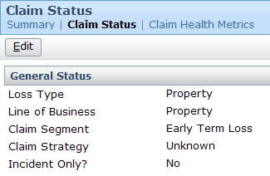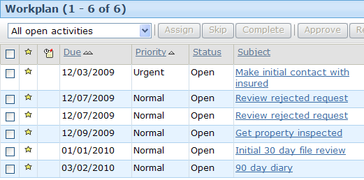

9. Log on as Ronald Barnes (rbarnes). Using policy 23-502011, create a property claim whose loss date is two months after the policy effective date. Make sure to assign the claim to Ronald Barnes. Verify that:
- The claim is not segmented as "early_term_loss"
- The claim's workplan does not have a property inspection and a 90-day diary activity.

